N-gonal Bipyramid

Definition
# Source: AI Source: Provided by: [Data Path: Persons Table -> ID Column: 1, Name_En Column: Motasem Essam] -> From: [ChatGPT] on [7/25/2026]
An N-gonal Bipyramid is a three-dimensional polyhedron formed by joining two N-gonal pyramids at their congruent N-gonal bases.
The shared N-gonal base becomes an internal face, while the triangular lateral faces form the exterior surface.
It consists of:
- Two apexes positioned on opposite sides of a common N-gonal base.
- N vertices forming the shared N-gon.
- 2N external triangular faces.
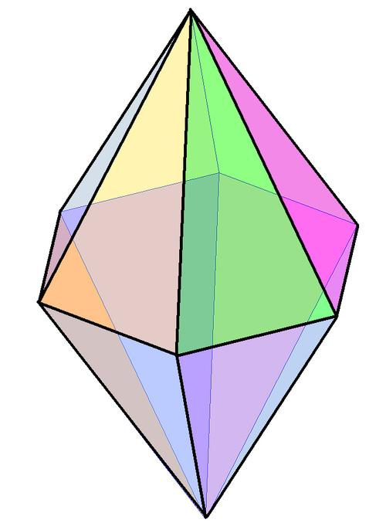
<caption>Example of an N-gonal bipyramid with a regular polygonal middle section and two opposite apexes.</caption>

Simple Definition
# Source: AI Source: Provided by: [Data Path: Persons Table -> ID Column: 1, Name_En Column: Motasem Essam] -> From: [ChatGPT] on [7/25/2026]
An N-gonal bipyramid is a solid made by joining two N-gonal pyramids base-to-base, creating a polyhedron with 2N triangular faces, 3N edges, and N + 2 vertices, where N is the number of sides of the central polygon.

Geometric Structure
# Source: AI Source: Provided by: [Data Path: Persons Table -> ID Column: 1, Name_En Column: Motasem Essam] -> From: [ChatGPT] on [7/25/2026]
The N-gonal bipyramid has three main structural components:
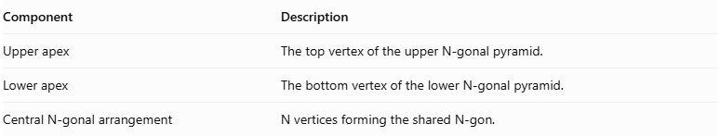
Component | Description
Upper apex | The top vertex of the upper N-gonal pyramid.
Lower apex | The bottom vertex of the lower N-gonal pyramid.
Central N-gonal arrangement | N vertices forming the shared N-gon.
Both apexes are connected to all N vertices of the central N-gon.
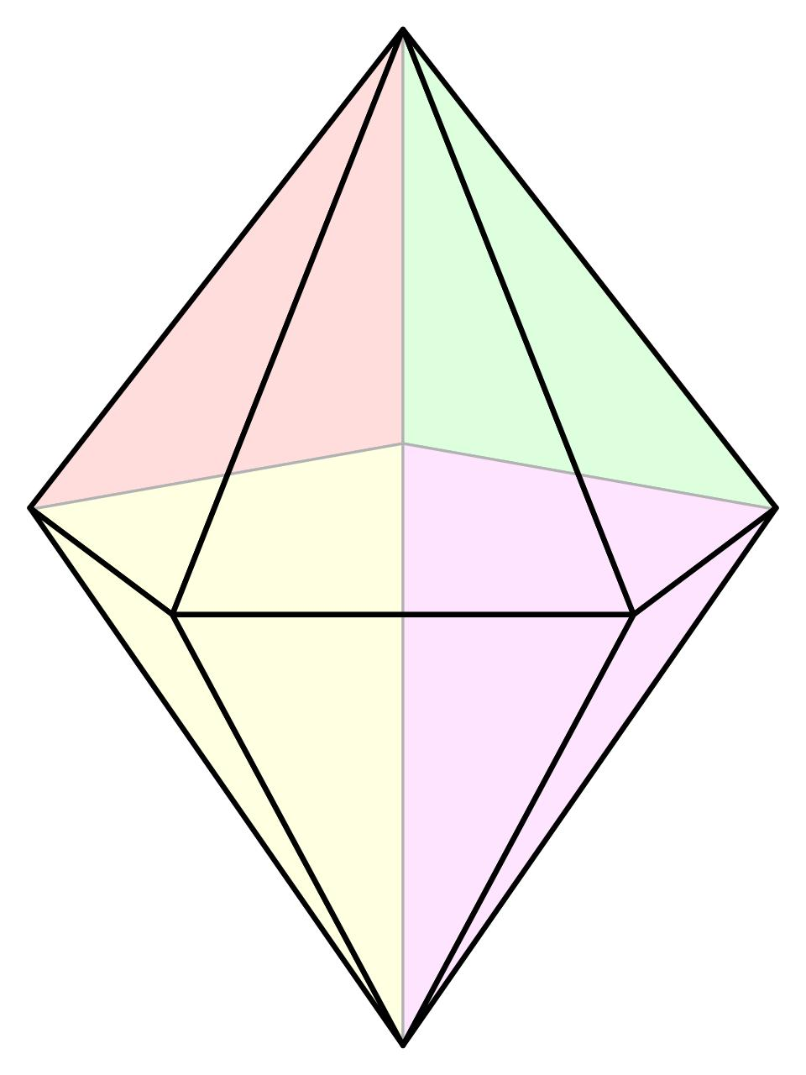

Face Structure
# Source: AI Source: Provided by: [Data Path: Persons Table -> ID Column: 1, Name_En Column: Motasem Essam] -> From: [ChatGPT] on [7/25/2026]
An N-gonal bipyramid has 2N external triangular faces.
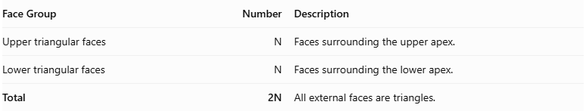
Face Group | Number | Description
Upper triangular faces | $$N$$ | Faces surrounding the upper apex.
Lower triangular faces | $$N$$ | Faces surrounding the lower apex.
Total | 2N | All external faces are triangles.
The common N-gonal base is internal, so it is not counted as an external face.

Edge Structure
# Source: AI Source: Provided by: [Data Path: Persons Table -> ID Column: 1, Name_En Column: Motasem Essam] -> From: [ChatGPT] on [7/25/2026]
The solid has 3N edges, divided into three groups:
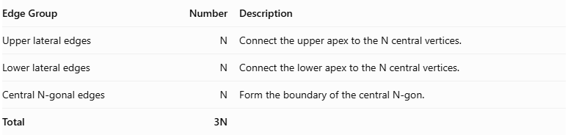
Edge Group | Number | Description
Upper lateral edges | $$N$$ | Connect the upper apex to the N central vertices.
Lower lateral edges | $$N$$ | Connect the lower apex to the N central vertices.
Central N-gonal edges | $$N$$ | Form the boundary of the central N-gon.
Total | 3N
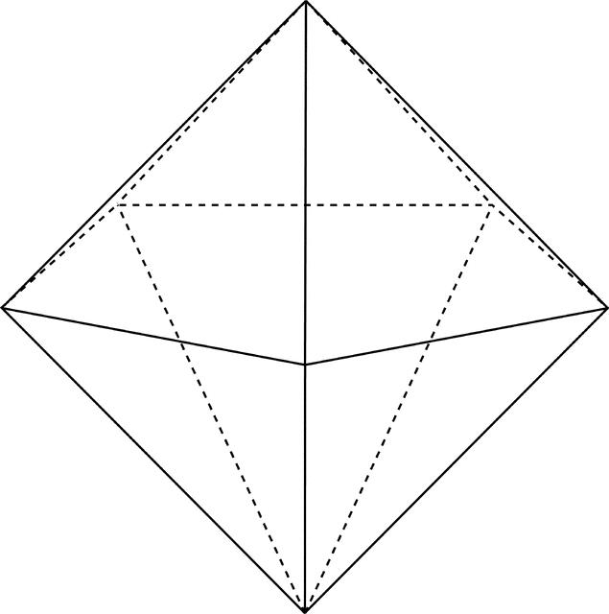

Vertex Structure
# Source: AI Source: Provided by: [Data Path: Persons Table -> ID Column: 1, Name_En Column: Motasem Essam] -> From: [ChatGPT] on [7/25/2026]
An N-gonal bipyramid has N + 2 vertices.
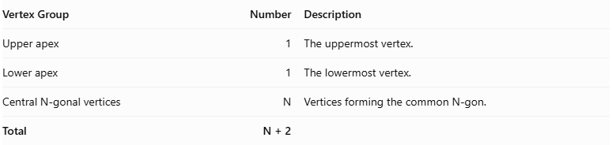
Vertex Group | Number | Description
Upper apex | 1 | The uppermost vertex.
Lower apex | 1 | The lowermost vertex.
Central N-gonal vertices | $$N$$ | Vertices forming the common N-gon.
Total | N + 2

Mathematical Properties
# Source: AI Source: Provided by: [Data Path: Persons Table -> ID Column: 1, Name_En Column: Motasem Essam] -> From: [ChatGPT] on [7/25/2026]
For an N-gonal bipyramid, where N is an integer greater than or equal to 3:
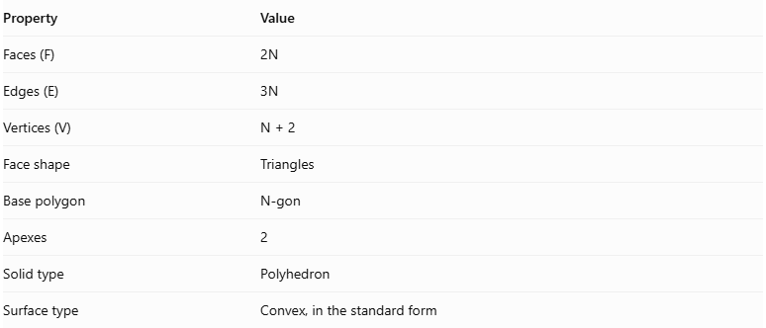
Property | Value
Faces (F) | $$2N$$
Edges (E) | $$3N$$
Vertices (V) | $$N+2$$
Face shape | Triangles
Base polygon | N-gon
Apexes | 2
Solid type | Polyhedron
Surface type | Convex, in the standard form
It satisfies Euler's polyhedron formula:
$$V-E+F=2$$
Substituting:
$$(N+2)-3N+2N=2$$
Therefore, the N-gonal bipyramid satisfies Euler's formula.

Face Incidence
# Source: AI Source: Provided by: [Data Path: Persons Table -> ID Column: 1, Name_En Column: Motasem Essam] -> From: [ChatGPT] on [7/25/2026]
In the standard N-gonal bipyramid:
- Each apex is shared by N triangular faces.
- Each central N-gonal vertex is shared by 4 triangular faces.
- Every external edge belongs to exactly two triangular faces.
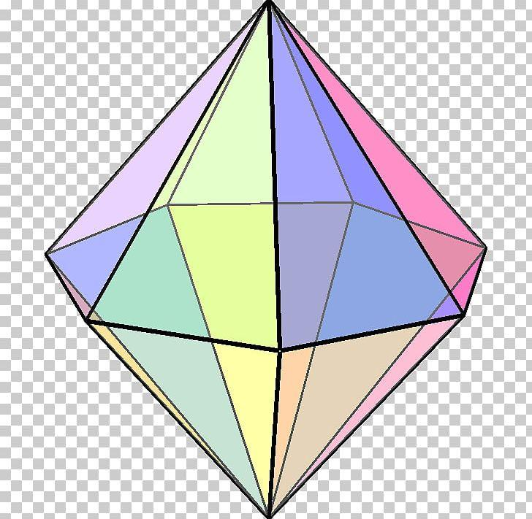

Surface Area and Volume

Surface Area
# Source: AI Source: Provided by: [Data Path: Persons Table -> ID Column: 1, Name_En Column: Motasem Essam] -> From: [ChatGPT] on [7/25/2026]
The total surface area is the sum of the areas of the 2N external triangular faces.
$$S=S_{u}+S_{l}$$
Where:
- $S_{u}$ = total area of the N upper triangular faces.
- $S_{l}$ = total area of the N lower triangular faces.
If the upper and lower pyramids are congruent:
$$S=2S_{p}$$
For a regular N-gonal base with side length $s$ and upper and lower slant heights $l_{u}$ and $l_{l}$:
$$\boxed{S=\frac{Ns}{2}(l_{u}+l_{l})}$$
If they are congruent and have the same slant height $l$:
$$\boxed{S=Nsl}$$

Volume
# Source: AI Source: Provided by: [Data Path: Persons Table -> ID Column: 1, Name_En Column: Motasem Essam] -> From: [ChatGPT] on [7/25/2026]
The volume is the sum of the volumes of the two N-gonal pyramids.
$$V=\frac{1}{3}{Bh}_{u}+\frac{1}{3}{Bh}_{l}$$
Therefore:
$$\boxed{V=\frac{1}{3}B(h_{u}+h_{l})}$$
Where:
- $B$ = area of the common N-gonal base.
- $h_{u}$ = height of the upper pyramid.
- $h_{l}$ = height of the lower pyramid.
For a regular N-gon with side length $s$:
$$B=\frac{{Ns}^{2}}{4tan({180}^{∘}/N)}$$
Therefore:
$$\boxed{V=\frac{{Ns}^{2}(h_{u}+h_{l})}{12tan({180}^{∘}/N)}}$$

Symmetry
# Source: AI Source: Provided by: [Data Path: Persons Table -> ID Column: 1, Name_En Column: Motasem Essam] -> From: [ChatGPT] on [7/25/2026]
A regular N-gonal bipyramid with congruent upper and lower pyramids has the following symmetry properties:
- N-fold rotational symmetry: Rotation by ${360}^{∘}/N$ around the central axis leaves the solid unchanged.
- Vertical reflection planes: N planes pass through the central axis and the symmetry axes of the regular N-gon.
- Horizontal reflection plane: The central N-gonal plane reflects the upper half onto the lower half.
- Central inversion symmetry: Present when N is even and the two apexes are equally distant from the center on opposite sides of the base plane.
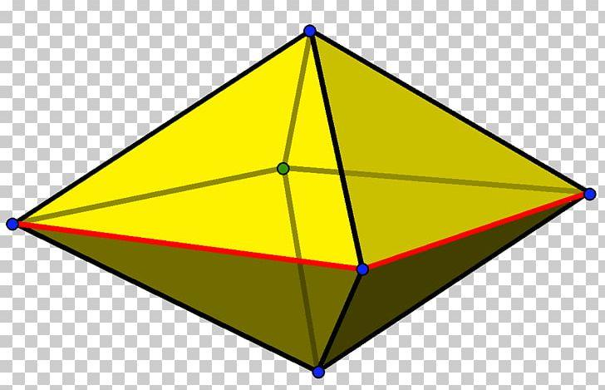

Relationship to Other Solids
# Source: AI Source: Provided by: [Data Path: Persons Table -> ID Column: 1, Name_En Column: Motasem Essam] -> From: [ChatGPT] on [7/25/2026]
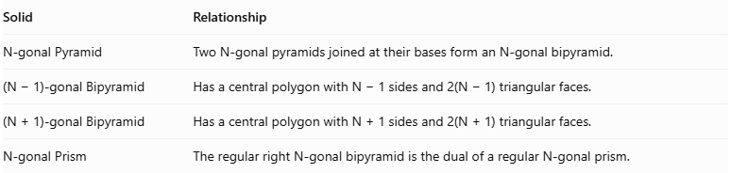
Solid | Relationship
N-gonal Pyramid | Two N-gonal pyramids joined at their bases form an N-gonal bipyramid.
(N − 1)-gonal Bipyramid | Has a central polygon with N − 1 sides and 2(N − 1) triangular faces.
$$(N+1)-gonalBipyramid$$ | $$HasacentralpolygonwithN+1sidesand2(N+1)triangularfaces.$$
N-gonal Prism | The regular right N-gonal bipyramid is the dual of a regular N-gonal prism.

Worked Examples

Example 1: Calculate Faces, Edges, and Vertices
# Source: AI Source: Provided by: [Data Path: Persons Table -> ID Column: 1, Name_En Column: Motasem Essam] -> From: [ChatGPT] on [7/25/2026]
For an N-gonal bipyramid:
$$F=2N, E=3N, V=N+2$$
If N = 8:
- Faces = $2(8)=16$
- Edges = $3(8)=24$
- Vertices = $8+2=10$

Example 2: Calculate Volume
# Source: AI Source: Provided by: [Data Path: Persons Table -> ID Column: 1, Name_En Column: Motasem Essam] -> From: [ChatGPT] on [7/25/2026]
Given:
- Base area $B=40{\text{ cm}}^{2}$
- Upper height $h_{u}=6\text{ cm}$
- Lower height $h_{l}=9\text{ cm}$
Using:
$$V=\frac{1}{3}B(h_{u}+h_{l})$$
$$V=\frac{1}{3}(40)(6+9)$$
$$V=\frac{600}{3}$$
$$\boxed{V=200{\text{ cm}}^{3}}$$

Constructing N-gonal Bipyramid in Solid Geometry

Geometric Instruments Used
# Source: AI Source: Provided by: [Data Path: Persons Table -> ID Column: 1, Name_En Column: Motasem Essam] -> From: [ChatGPT] on [7/25/2026]

- Ruler: Drawing straight lines and edges.
- Compass: Drawing circles and marking equal distances.
- Protractor: Dividing the circle into equal angles.
- Set square: Constructing perpendicular lines.
- Pencil: Drawing construction lines.
- Eraser: Removing unnecessary construction marks.

Instrument-Based Construction Procedures

A. Constructing N-gonal Base
# Source: AI Source: Provided by: [Data Path: Persons Table -> ID Column: 1, Name_En Column: Motasem Essam] -> From: [ChatGPT] on [7/25/2026]
- Draw a circle using a compass.
- Mark its center.
- Divide the circle into N equal angular sections using a protractor.
- Calculate the central angle:
$$θ=\frac{{360}^{∘}}{N}$$
- Mark the N points around the circle.
- Connect consecutive points using a ruler.
- Complete the regular N-gonal base.

B. Constructing First Pyramid
# Source: AI Source: Provided by: [Data Path: Persons Table -> ID Column: 1, Name_En Column: Motasem Essam] -> From: [ChatGPT] on [7/25/2026]
- Identify the center of the N-gonal base.
- Construct a perpendicular line through the center.
- Mark the upper apex above the base plane.
- Connect the upper apex to all N vertices.
- Form N triangular lateral faces.

C. Constructing Second Pyramid
# Source: AI Source: Provided by: [Data Path: Persons Table -> ID Column: 1, Name_En Column: Motasem Essam] -> From: [ChatGPT] on [7/25/2026]
- Extend the perpendicular axis in the opposite direction.
- Mark the second apex below the base plane.
- Connect the lower apex to all N vertices.
- Form another N triangular lateral faces.

D. Completing the Bipyramid
# Source: AI Source: Provided by: [Data Path: Persons Table -> ID Column: 1, Name_En Column: Motasem Essam] -> From: [ChatGPT] on [7/25/2026]
- Check that both pyramids share the same N-gonal base.
- Ensure that the two apexes are on opposite sides of the base plane.
- Darken the visible external edges.
- Draw hidden edges using dashed lines when necessary.
- Remove unnecessary construction marks.
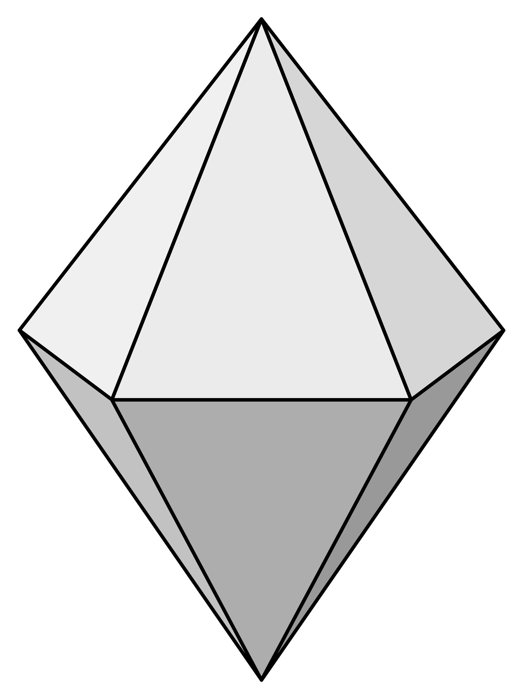

Key Points
# Source: AI Source: Provided by: [Data Path: Persons Table -> ID Column: 1, Name_En Column: Motasem Essam] -> From: [ChatGPT] on [7/25/2026]
- An N-gonal bipyramid is formed by joining two N-gonal pyramids at their bases.
- It has 2N external triangular faces.
- It has 3N edges.
- It has N + 2 vertices.
- The common N-gonal base is internal and is not counted as an external face.
- Its volume is the sum of the volumes of the two pyramids.
- A regular N-gonal bipyramid has N-fold rotational symmetry.

Conclusion
# Source: AI Source: Provided by: [Data Path: Persons Table -> ID Column: 1, Name_En Column: Motasem Essam] -> From: [ChatGPT] on [7/25/2026]
An N-gonal Bipyramid is a polyhedron formed by combining two N-gonal pyramids around a shared N-gonal base. It has 2N triangular faces, 3N edges, and N + 2 vertices.
Its defining characteristic is the N-sided central arrangement connecting the upper and lower apexes.
Image references: The illustrations above are visual references for the general bipyramid structure and its construction. The mathematical formulas and structural properties are supported by the cited geometry references.

